**ASsessment-2**

**S.praveen Kumar**

**Ch.en.u4aie22048**

**1)DIVISION OPERATION**

**AIM:**

To execute division operation in CPU emulator using Hack Assembly Language.

**HACK ASSEMBLY CODE:**

|  |  |
| --- | --- |
| 0 | @1 |
| 1 | D=M |
| 2 | @16 |
| 3 | M=D |
| 4 | @2 |
| 5 | D=M |
| 6 | @17 |
| 7 | M=D |
| 8 | @18 |
| 9 | M=0 |
| 10 | @16 |
| 11 | D=M |
| 12 | @17 |
| 13 | D=D-M |
| 14 | @18 |
| 15 | D;JGE |
| 16 | @26 |
| 17 | 0;JMP |
| 18 | @18 |
| 19 | M=M+1 |
| 20 | @17 |
| 21 | D=M |
| 22 | @16 |
| 23 | M=M-D |
| 24 | @10 |
| 25 | 0;JMP |
| 26 | @18 |
| 27 | D=M |
|  |  |
| 28 | @3 |
| 29 | M=D |
| 30 | @26 |
| 31 | 0;JMP |

**VERIFICATION SCREENSHOT:**

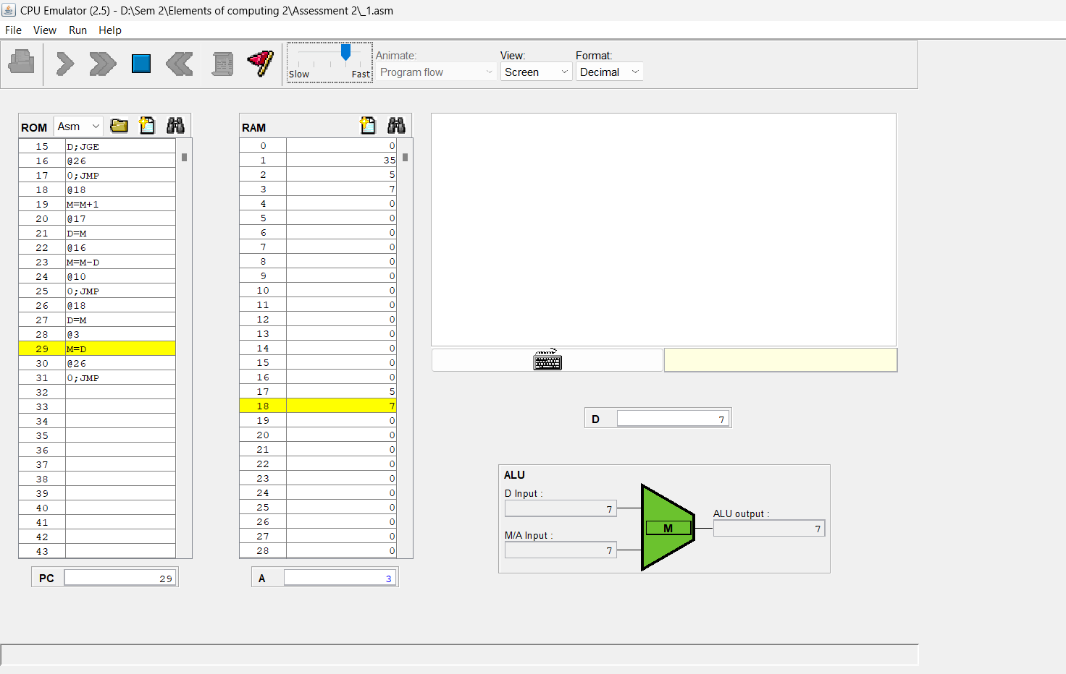

**RESULT:**

The Division operation is executed successfully using CPU emulator in Nand2tetris using Hack Assembly Language.

**2) The greatest among two numbers**

**AIM:**

To execute greatest among two numbers in CPU emulator using Hack Assembly Language.

**HACK ASSEMBLY CODE:**

|  |  |
| --- | --- |
| 0 | @0 |
| 1 | D=M |
| 2 | @16 |
| 3 | M=D |
| 4 | @1 |
| 5 | D=M |
| 6 | @17 |
| 7 | M=D |
| 8 | @16 |
| 9 | D=M |
| 10 | @17 |
| 11 | D=D-M |
| 12 | @16 |
| 13 | D;JGT |
| 14 | @22 |
| 15 | 0;JMP |
| 16 | @16 |
| 17 | D=M |
| 18 | @3 |
| 19 | M=D |
| 20 | @28 |
| 21 | 0;JMP |
| 22 | @17 |
| 23 | D=M |
| 24 | @3 |
| 25 | M=D |
| 26 | @28 |
| 27 | 0;JMP |
| 28 | @28 |
| 29 | 0;JMP |

**VERIFICATION SCREENSHOT:**

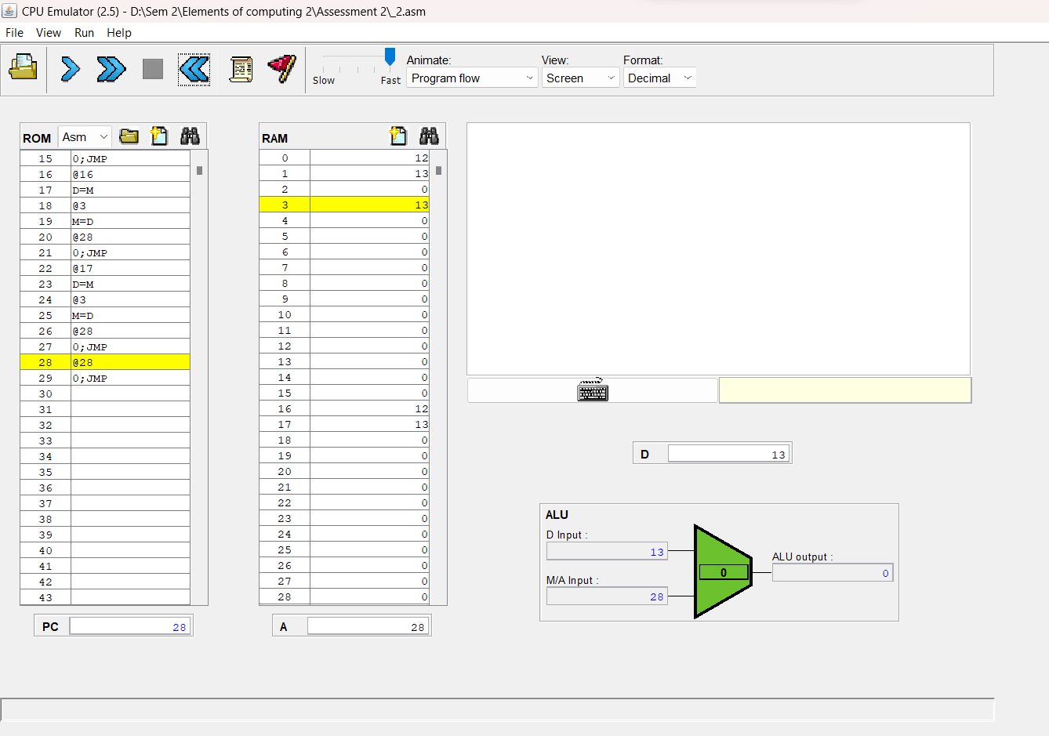

**RESULT:**

Find the greatest among the two numbers is executed successfully using CPU emulator in Nand2tetris using Hack Assembly Language.

**3) create an array of size 10 with values -1**

**AIM:**

To execute an array of size 10 with values -1 in CPU emulator using Hack Assembly Language.

**HACK ASSEMBLY CODE:**

|  |  |
| --- | --- |
| 0 | @0 |
| 1 | D=M |
| 2 | @16 |
| 3 | M=D |
| 4 | @1 |
| 5 | D=M |
| 6 | @17 |
| 7 | M=D |
| 8 | @17 |
| 9 | D=M |
| 10 | @21 |
| 11 | D;JLE |
| 12 | @16 |
| 13 | A=M |
| 14 | M=-1 |
| 15 | @16 |
| 16 | M=M+1 |
| 17 | @17 |
| 18 | M=M-1 |
| 19 | @8 |
| 20 | 0;JMP |
| 21 | @21 |
| 22 | 0;JMP |

**VERIFICATION SCREENSHOT:**

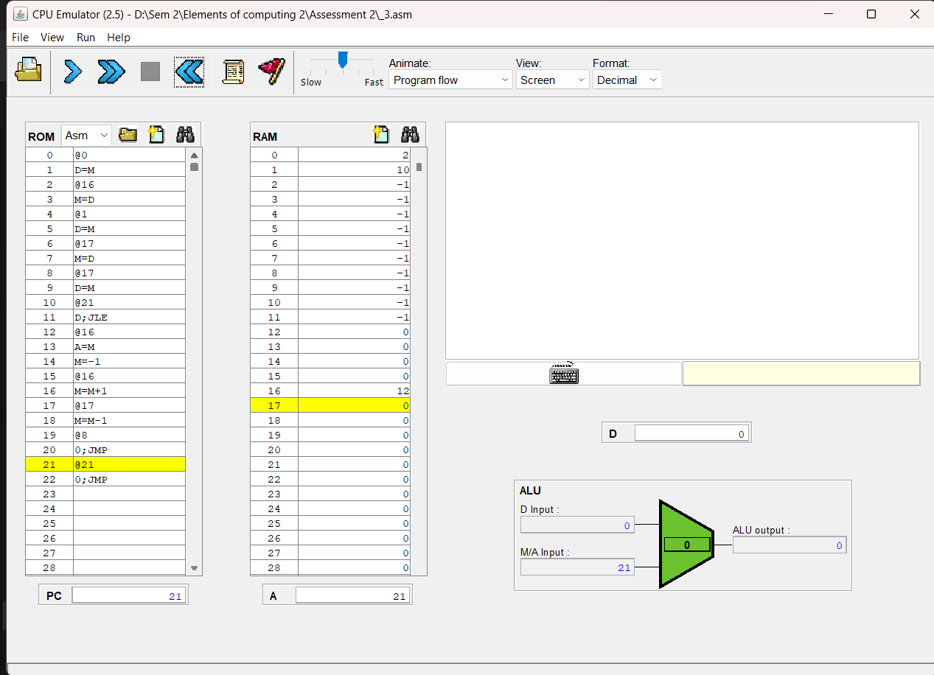

**RESULT:**

Creating an array with size 10 with values -1 is executed successfully using CPU emulator in Nand2tetris using Hack Assembly Language.

**4) Draw a rectangle at the upper right corner of the screen.**

**AIM:**

To execute a rectangle at the upper right corner of the screen in CPU emulator using Hack Assembly Language.

**HACK ASSEMBLY CODE:**

|  |  |
| --- | --- |
| 0 | @16384 |
| 1 | D=A |
| 2 | @16 |
| 3 | M=D |
| 4 | @12 |
| 5 | D=A |
| 6 | @17 |
| 7 | M=D |
| 8 | @16 |
| 9 | D=A |
| 10 | @18 |
| 11 | M=D |
| 12 | @16 |
| 13 | A=M |
| 14 | M=-1 |
| 15 | @16 |
| 16 | M=M+1 |
| 17 | @18 |
| 18 | M=M-1 |
| 19 | @18 |
| 20 | D=M |
| 21 | @12 |
| 22 | D;JGT |
| 23 | @25 |
| 24 | 0;JMP |
| 25 | @16 |
| 26 | D=A |
| 27 | @16 |
| 28 | M=D+M |
| 29 | @17 |
| 30 | M=M-1 |
| 31 | @17 |
| 32 | D=M |
| 33 | @8 |
| 34 | D;JGT |
| 35 | @37 |
| 36 | 0;JMP |
| 37 | @100 |
| 38 | D=A |
| 39 | @19 |
| 40 | M=D |
| 41 | @1 |
| 42 | D=A |
| 43 | @20 |
| 44 | M=D |
| 45 | @16 |
| 46 | A=M |
| 47 | M=-1 |
| 48 | @16 |
| 49 | M=M+1 |
| 50 | @20 |
| 51 | M=M-1 |
| 52 | D=M |
| 53 | @45 |
| 54 | D;JGT |
| 55 | @57 |
| 56 | 0;JMP |
| 57 | @14 |
| 58 | D=A |
| 59 | @16 |
| 60 | M=D+M |
| 61 | @1 |
| 62 | D=A |
| 63 | @20 |
| 64 | M=D |
| 65 | @16 |
| 66 | A=M |
| 67 | M=-1 |
| 68 | @16 |
| 69 | M=M+1 |
| 70 | @20 |
| 71 | M=M-1 |
| 72 | D=M |
| 73 | @65 |
| 74 | D;JGT |
| 75 | @77 |
| 76 | 0;JMP |
| 77 | @16 |
| 78 | D=A |
| 79 | @16 |
| 80 | M=D+M |
| 81 | @19 |
| 82 | M=M-1 |
| 83 | D=M |
| 84 | @41 |
| 85 | D;JGT |
| 86 | @88 |
| 87 | 0;JMP |
| 88 | @12 |
| 89 | D=A |
| 90 | @21 |
| 91 | M=D |
| 92 | @16 |
| 93 | D=A |
| 94 | @22 |
| 95 | M=D |
| 96 | @16 |
| 97 | A=M |
| 98 | M=-1 |
| 99 | @16 |
| 100 | M=M+1 |
| 101 | @22 |
| 102 | M=M-1 |
| 103 | D=M |
| 104 | @96 |
| 105 | D;JGT |
| 106 | @108 |
| 107 | 0;JMP |
| 108 | @16 |
| 109 | D=A |
| 110 | @16 |
| 111 | M=D+M |
| 112 | @21 |
| 113 | M=M-1 |
| 114 | D=M |
| 115 | @92 |
| 116 | D;JGT |
| 117 | @119 |
| 118 | 0;JMP |
| 119 | @119 |
| 120 | 0;JMP |

**VERIFICATION SCREENSHOT:**

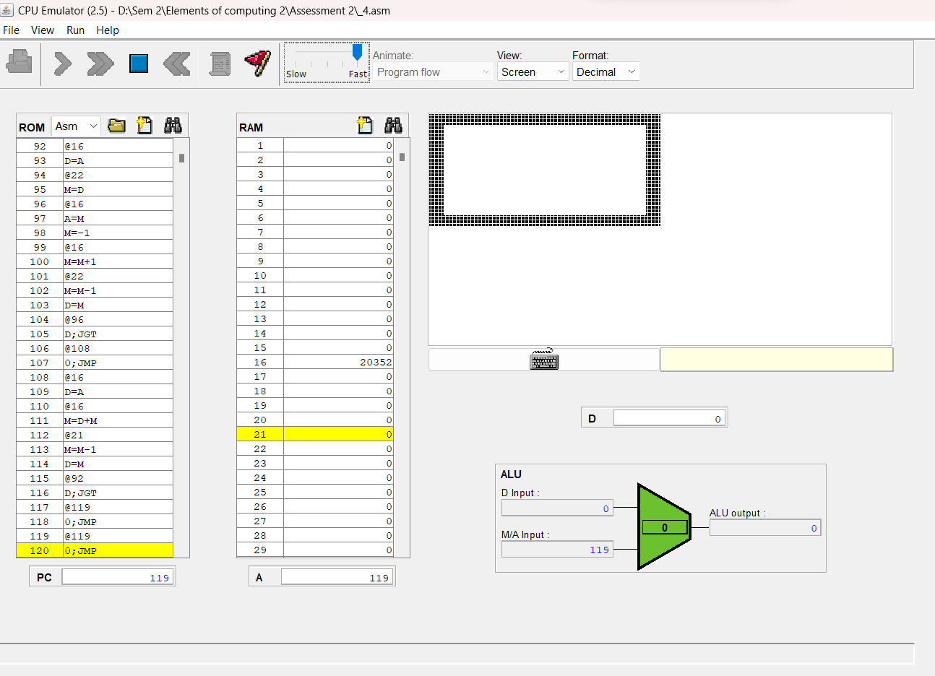

**RESULT:**

Draw a rectangle at the upper right corner of the screen is executed successfully using CPU emulator in Nand2tetris using Hack Assembly Language.

**5) blacken the entire pixels on the screen on a keypress by the user.**

**AIM:**

To execute blacken the entire pixels on the screen on a keypress by the user in CPU emulator using Hack Assembly Language.

**HACK ASSEMBLY CODE:**

|  |  |
| --- | --- |
| 0 | @8192 |
| 1 | D=A |
| 2 | @16 |
| 3 | M=D |
| 4 | @16 |
| 5 | M=M-1 |
| 6 | D=M |
| 7 | @0 |
| 8 | D;JLT |
| 9 | @24576 |
| 10 | D=M |
| 11 | @22 |
| 12 | D;JEQ |
| 13 | @15 |
| 14 | 0;JMP |
| 15 | @16384 |
| 16 | D=A |
| 17 | @16 |
| 18 | A=D+M |
| 19 | M=-1 |
| 20 | @4 |
| 21 | 0;JMP |
| 22 | @16384 |
| 23 | D=A |
| 24 | @16 |
| 25 | A=D+M |
| 26 | M=0 |
| 27 | @4 |
| 28 | 0;JMP |

**VERIFICATION SCREENSHOT:**

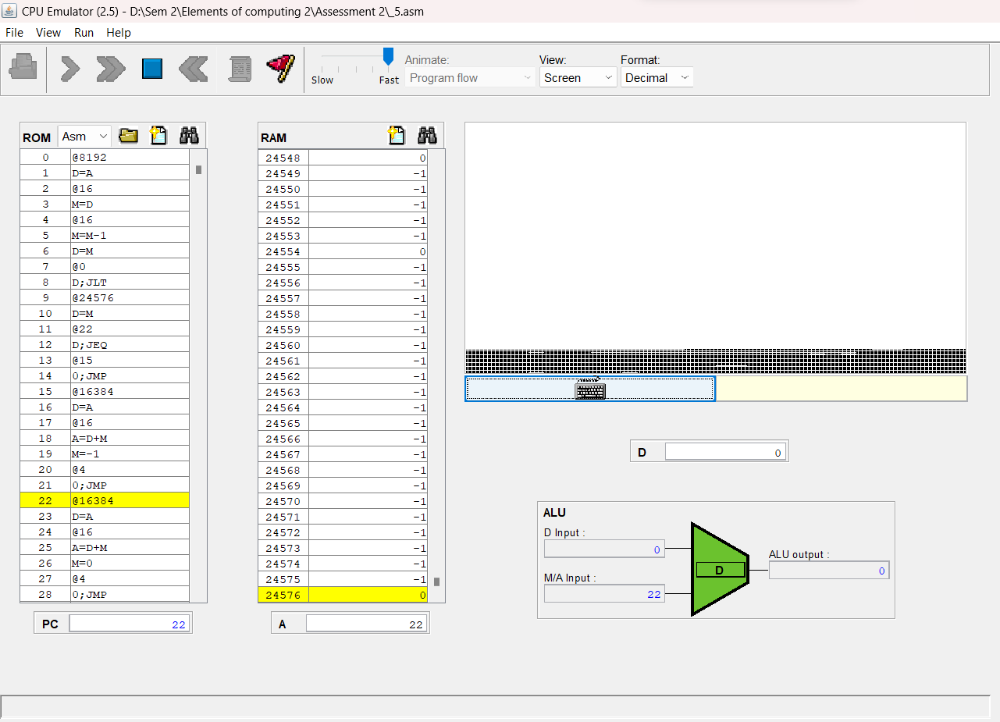

**RESULT:**

blacken the entire pixels on the screen on a keypress by the user is executed successfully using CPU emulator in Nand2tetris using Hack Assembly Language.